**Worksheet: Procedures**

**Scenario**

British Soaps UK is creating a new mobile phone app to remind you when your favourite soap is on. They’ve had someone write them a start for their main program, but they think you might be able to tidy it up a little.

1. Re-using code

The same five lines seem to keep appearing in the code.  
Define a procedure called **displayTime()** and cut/paste these five lines into it.  
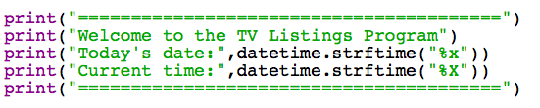

1. Wherever those five lines are in the program, replace them with the procedure call.  
   Check the program runs as it did before.
2. There is another block of five lines that repeats.

Define a procedure called **displayProgram()**, put the right code into it and call the procedure from the main program.

1. Looking at the code that is left, there still seems to be a repeating pattern.

Try putting this code into a loop that repeats four times. Your knowledge of lists and **for** loops might be very helpful here!